Fashion MNIST Classifier

**Project Details:**

The goal of this project is to develop a deep learning model that can accurately classify images of clothing items into one of ten categories using the Fashion MNIST dataset. The Fashion MNIST dataset is a popular alternative to the original MNIST dataset.

Challenges & Solutions

* **Challenge:** Ensuring that the data is in the correct format and normalized.
* **Solution:** Preprocess the images by normalizing the pixel values to a range of 0 to 1. This normalization helps in faster convergence during training.

Visuals : 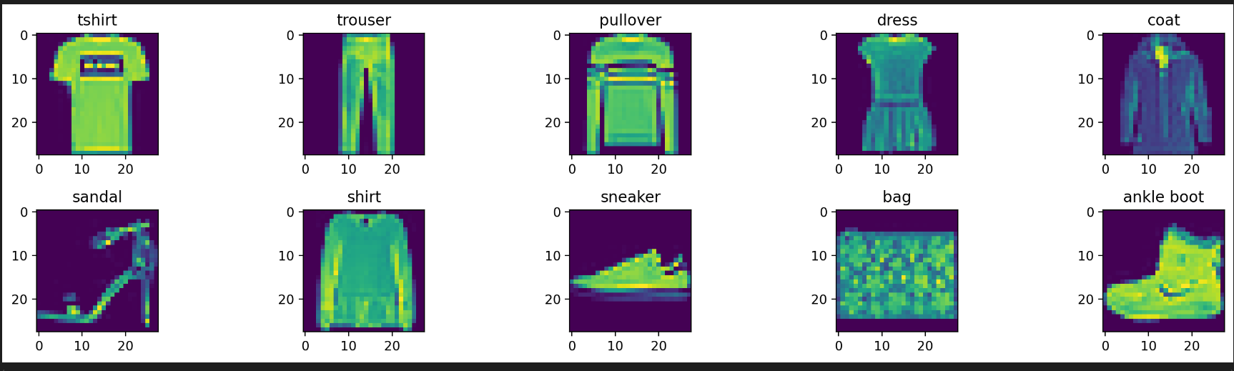

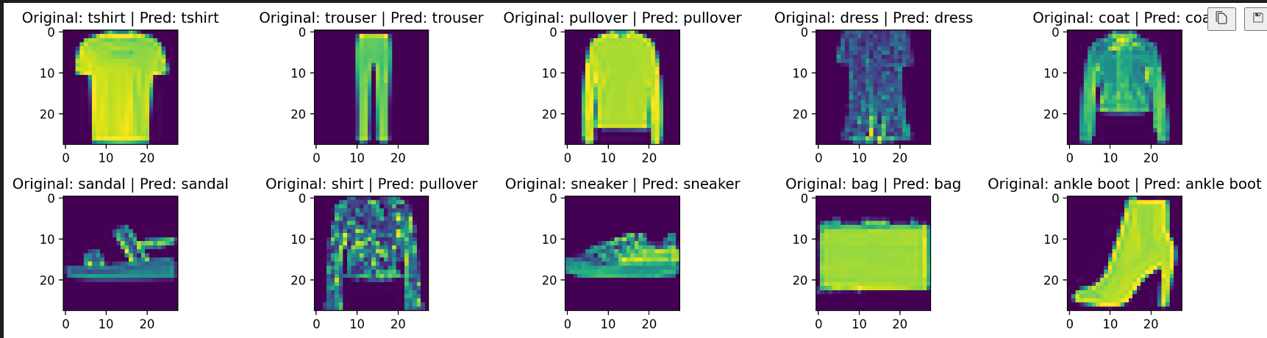

**References:**

* The Fashion MNIST Database
* Online courses on deep learning